VISUALLY CHALLENGED / DIFFERENTLY ABLED USERS SECTION

The Differently Abled users need special arrangements in the environment for their mobility and independent functioning. University Library has created special facilities such as ramps, rails and special rest rooms, and makes other necessary changes to suit the special needs of differently-abled and visually challenged users. In order to cater the needs, library provides aids for the disabilities viz., JAWS Talking software for the Blind, MaGic screen Magnification Software without Speech, MAGic Large Print Keyboard, Topaz 20” Inch desktop video Magnifier, Zoom Ex Instant Reader, SARA CF instant Text Reading Machine, Focus 40 Blue Refreshable Braille display and Ruby Handheld Video magnifier.

Talking Book Library has been Angle Pro Talking Daisy Player / E-Book Reader for the blind and also Braille Book Library has been Index Basic D-V4 Translation Software, Duxbury Braille Translation Software, Tractor Feed Braille Paper (1000 Sheets in 1 Box) and Acoustic Cabinet for sound proofing for the benefit of Visually Challenged / Differently Abled persons.

**Zoom-Ex Instant Text Reader**

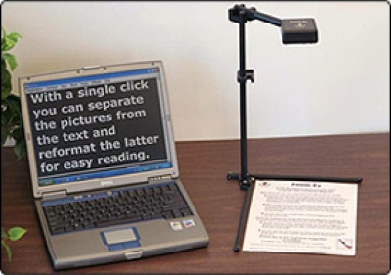

A High-Tech Reading Machine for the Visually Impaired and Deaf-Blind A portable USB device that scans books, documents and instantly converts printed text into multiple accessible formats viz., Speech/Magnified View/Large Print/Braille. Zoom-Ex is a small portable device that uses the new generation Motion Sensor technology in combination with its proprietary Zoom Office software to make scanning & instant reading of text fast and easy.

**TOPAZ XL HD**

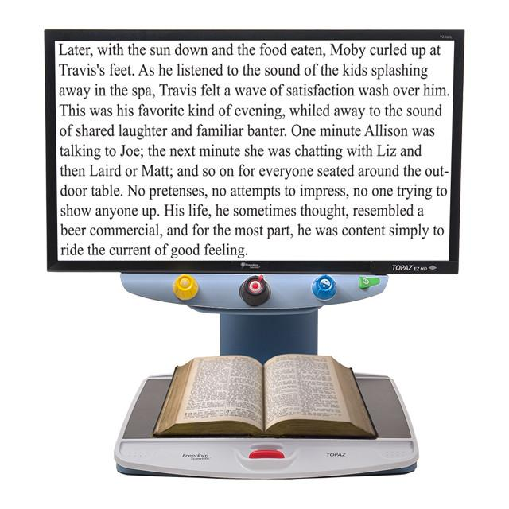

The TOPAZ XL HD brings you the most versatile desktop video magnifier available. The sharp image with high-contrast text, vibrant colors, and rich black and white, allows the TOPAZ XL HD to offer the lowest magnification (1.5x) and widest field of view of any desktop video magnifier. Many users find they can display an entire page of text in high contrast across a widescreen monitor and read without moving the reading table from side to side. This means less fatigue, faster reading, and better comprehension.

**SARA CE**

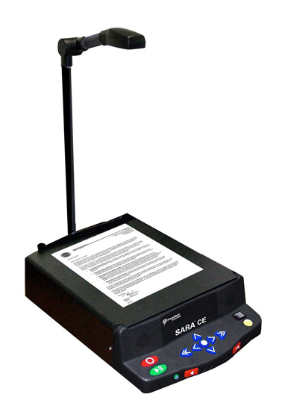

The SARA CE is simple to use. Just place a printed page under the camera, and the SARA CE instantly starts reading it to you with RealSpeak™ human-sounding speech. No computer experience is needed. You don’t even need to push a button to read almost any printed material – books, magazines, mail, and more. The camera automatically senses when a new page is presented.

**MAGic Large Print Keyboard**

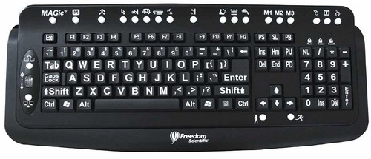

The MAGic Large Print Keyboard provides low vision users with an easyto-read keyboard with dedicated MAGic feature keys, making learning and using MAGic easier than ever.

**Easy to See**

The bold, high contrast keys provide fast, accurate typing with less of the eye fatigue experienced when straining to locate keys on standard keyboards.

**Single-key Control**

MAGic’s most-used functions are preassigned to single keys, providing quick access to these features. Press a single key to launch MAGic. Quickly zoom out to 1x to check your formatting and then return to your working magnification level. Toggle on and off visual enhancements for mouse, cursor, and focus tracking. Adjust reading speed on the fly. Control all these features and more with the 22 specialized keys.

**MAGic Screen Magnification**

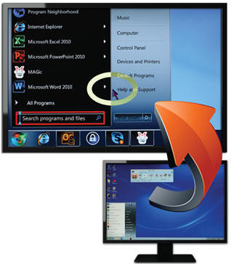

MAGic opens up a whole new world of computing to low vision users. Whether you are surfing the Web, creating a document, e-mailing, or engaging in social networking, MAGic provides you the tools you need to work more efficiently. MAGic’s high-definition text delivers smooth, crisp letters for all fonts, even at the highest magnification. MAGic features 46 magnification levels from 1x to 36x. MAGic is easy to learn and use with built-in training tools, text and audio training, talking installation, online Help, and context-sensitive Help for MAGic controls. MAGic with Speech features built-in human-sounding voices that you control independently for speaking text, mouse echo, and typing echo. Speech On Demand™ lets you easily access this aid only when you need it.

**Index V4 Embosser**

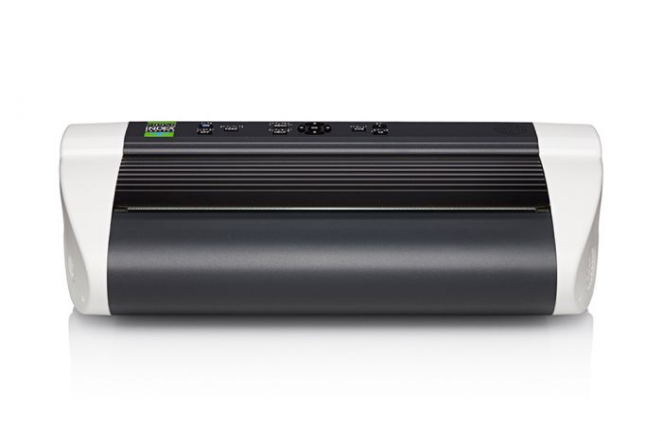

Basic-D is a small, portable and powerful Braille embosser. It is the top selling market leader of Braille printers for decades.

Double Sided and it produces 2 pages i.e. front and back at the same time.Uses Tractor Feed Continuous Sheet paper which can be spiral bound using plastic wire making it very economical and does not require any special binding equipment. Produces High Quality Braille Dots and continuous embossing for long hours: Load a box of continuous sheet Braille paper and it will emboss without interruption continuously for long hours, making Braille production a very simple task Portable, Durable and Stable and user friendly, easy to operate giving trouble free performance

**Focus 40 Blue**

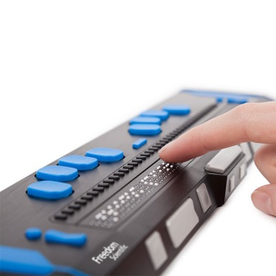

The new Focus 40 Blue combines the latest Braille technology, a comfortable keyboard and control layout, and both USB and Bluetooth connectivity in an extremely lightweight and compact design. Use the Focus 40 Blue with Braille In to enter Contracted Braille, switch to display modes such as structured and line mode, or perform all keyboard commands for complete control of your PC. The comfort and response of the refined Perkins-style keyboard permits hours of effortless Braille text input.

**Angel Pro Daisy Reader**

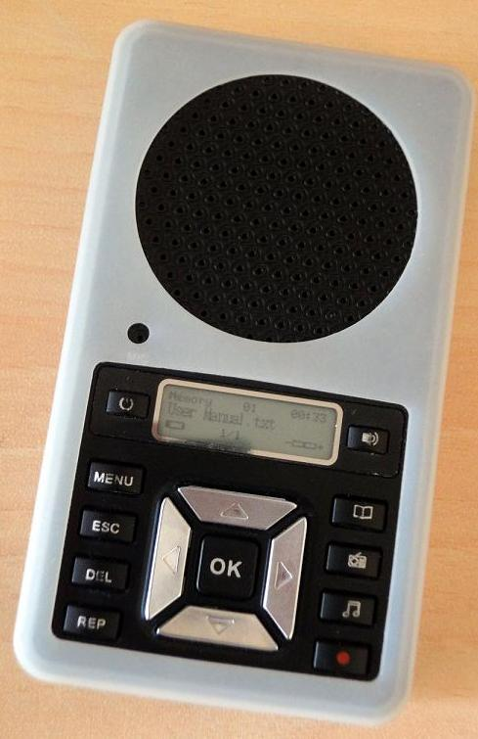

The Angel Pro is an All in One Talking Digital Daisy Reader/ E-book Reader/ MP3 Player/ Voice Recorder. This small pocket device offers several advantages to the blind students, in many ways as explained below: DAISY READER: Reads all Daisy Talking books prepared in all format and it does not matter in what language they have been produced. English books of course can be displayed on the screen; however the other languages will only speak the audio aspect. DAISY NAVIGATION: Provides easy navigation for direct access to Go to Page, Headings, with levels for chapters, sections, phrase as well as beginning of book, end of book, time intervals, etc. This helps the students to study their text books easily since earlier it was a major problem to directly access any specific chapter, page or section in recorded Talking Books in languages such as English, Hindi, Tamil etc. in CDs or cassettes.

**JAWS Software**

JAWS is a powerful screen reading software with Braille support providing access to computers to the blind students. It is available in bilingual edition i.e. English and Hindi languages that offers a very high level of accessibility and efficiency to the blind and low vision students. It is the only software in the world that also provides accessibility for E-learning by the visually impaired! It converts a standard PC into a talking computer; therefore this software enables them to independently write their notes, exams or lessons. JAWS Pro screen reading Software has an Indian accent voice Veena for English Language & Lekha for Hindi language for easy understanding thus enabling blind students to operate the computer independently in all Microsoft Windows applications including MS Office i.e. MS Word, MS Excel, MS PowerPoint, Internet Explorer, Outlook Express, etc. It is compatible to work with Win 2000/ XP, even Windows 7 and now even Windows 8.1.